SYSTEM SOFTWARE AND OPERATING SYSTEM LABORATORY
[As per Choice Based Credit System (CBCS) scheme]
(Effective from the academic year 2016 -2017)
SEMESTER – VI
Subject Code | 15CSL67 | IA Marks 20
Number of Lecture Hours/Week | 01I + 02P | Exam Marks 80
Total Number of Lecture Hours | 40 | Exam Hours 03

Description (If any): Exercises to be prepared with minimum three files (Where ever necessary):
i. Header file.
ii. Implementation file.
iii. Application file where main function will be present.
The idea behind using three files is to differentiate between the developer and user sides. In the developer side, all the three files could be made visible. For the user side only header file and application files could be made visible, which means that the object code of the implementation file could be given to the user along with the interface given in the header file, hiding the source file, if required. Avoid I/O operations (printf/scanf) and use data input file where ever it is possible

Laboratory Experiments

1. a) Write a LEX program to recognize valid arithmetic expression. Identifiers in the expression could be only integers and operators could be + and *. Count the identifiers & operators present and print them separately.
b) Write YACC program to evaluate arithmetic expression involving operators: +, -, *, and /.
2. Develop, Implement and execute a program using YACC tool to recognize all strings ending with b preceded by n a’s using the grammar a n b (note: input n value).
3. Design, develop and implement YACC/C program to construct Predictive / LL(1) Parsing Table for the grammar rules: A →aBa , B →bB | ε. Use this table to parse the sentence: abba$.
4. Design, develop and implement YACC/C program to demonstrate Shift Reduce Parsing technique for the grammar rules: E →E+T | T, T →T*F | F, F →(E) | id and parse the sentence: id + id * id.
5. Design, develop and implement a C/Java program to generate the machine code using Triples for the statement A = -B * (C +D) whose intermediate code in three-address form:
T1 = -B
T2 = C + D
T3 = T1 + T2
A = T3

6. a) Write a LEX program to eliminate comment lines in a C program and copy the resulting program into a separate file.
b) Write YACC program to recognize valid identifier, operators and keywords in the given text (C program) file.

7. Design, develop and implement a C/C++/Java program to simulate the working of Shortest remaining time and Round Robin (RR) scheduling algorithms. Experiment with different quantum sizes for RR algorithm.
8. Design, develop and implement a C/C++/Java program to implement Banker’s algorithm. Assume suitable input required to demonstrate the results.
9. Design, develop and implement a C/C++/Java program to implement page replacement algorithms LRU and FIFO. Assume suitable input required to demonstrate the results.

Conduction of Practical Examination:
• All laboratory experiments are to be included for practical examination.
• Students are allowed to pick one experiment from the lot.
• Strictly follow the instructions as printed on the cover page of answer script
• Marks distribution: Procedure + Conduction + Viva:20 + 50 +10 (80)
• Change of experiment is allowed only once and marks allotted to the procedure part to be made zero

1. Write a LEX program to recognize valid arithmetic expression. Identifiers in the expression could be only integers and operators could be + and *. Count the identifiers & operators present and print them separately.

%{
#include<stdio.h>
int v=0,op=0,id=0,flag=0;
%}
%%
[a-zA-Z]+[0-9A-Za-z]* {id++;printf("\n Identifier:");ECHO;}
[\+\-\*\/\=] {op++;printf("\n Operartor:");ECHO;}
"(" {v++;}
")" {v--;}
";" {flag=1;}
.|\n {;} %%
Void main()
{
printf("Enter the expression");
yylex();
if((op+1) ==id && v==0 && flag==0)
printf("\n Expression is Valid\n");
else
printf("\n Expression is Invalid\n");
}

Execution Steps:
Lex <lexfilename.l>
cc lex.yy.c –ll
. /a.out

Output:

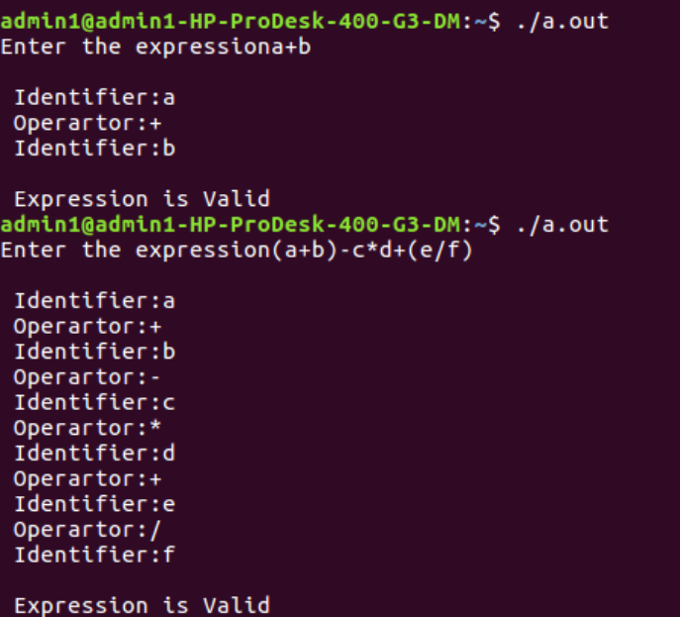

b. Write YACC program to evaluate arithmetic expression involving operators: +, -, *, and /

Lex Part

%{
#include "y.tab.h"
extern yylval;
%}
%%
[0-9]+ {yylval=atoi(yytext);return num;} /* convert the string to number and
send the value*/
[\+\-\*\/] {return yytext[0];}
[)] {return yytext[0];}
[(] {return yytext[0];}
. {;}
\n {return 0;}
%%

YACC Part

%{
#include<stdio.h>
#include<stdlib.h>
%}
%token num `
%left '+' '-'
%left '*' '/'
%%
input:exp {printf("%d\n",$$);exit(0);}
exp:exp'+'exp {$$=$1+$3;}
|exp'-'exp{$$=$1-$3;}
|exp'*'exp{$$=$1*$3;}
|exp'/'exp { if($3==0){printf("Divide by Zero\n");exit(0);}
else
$$=$1/$3;}
|'('exp')'{$$=$2;}
|num{$$=$1;};
%%
int yyerror()
{
printf("error");
exit(0);
}
int main()
{
printf("Enter an expression:\n");
yyparse();
}
Output:
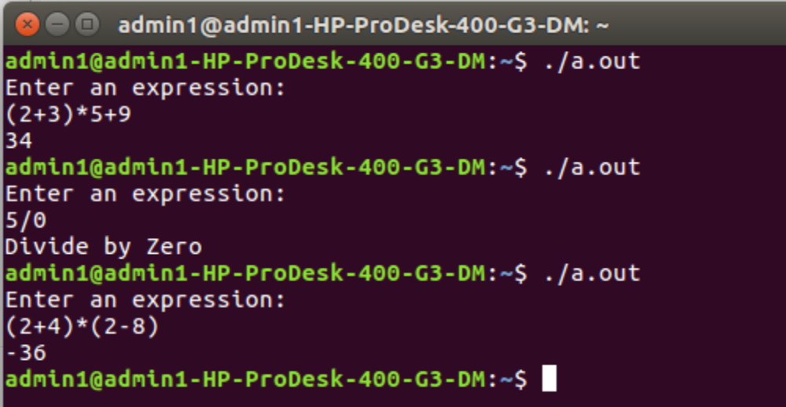

2. Develop, Implement and execute a program using YACC tool to recognize all strings ending with b preceded by n a’s using the grammar a n b (note: input n value).

Lex Part

%{
#include "y.tab.h"
%}
%%
a {return A;}
b {return B;}
[\n] return '\n';
%%

YACC Part

%{
#include<stdio.h>
#include<stdlib.h>
%}
%token A B
%%
input:s'\n' {printf("Successful Grammar\n");exit(0);}
s: A s1 B| B
s1: ; | A s1
%%
Void main()
{
printf("Enter A String\n");
yyparse();
}
int yyerror()
{
printf("Error \n");
exit(0);
}

Output:
N=2
aab valid string
N=2
ab invalid string

3. Design, develop and implement YACC/C program to construct Predictive / LL(1) Parsing Table for the grammar rules: A →aBa , B →bB | ε. Use this table to parse the sentence: abba$.

#include<stdio.h>
#include<conio.h>
#include<string.h>
void main()
{
char fin[10][20],st[10][20],ft[20][20],fol[20][20];
int a=0,e,i,t,b,c,n,k,l=0,j,s,m,p;
printf("enter the no. of coordinates\n");
scanf("%d",&n);
printf("enter the productions in a grammar\n");
for(i=0;i<n;i++)
scanf("%s",st[i]);
for(i=0;i<n;i++)
fol[i][0]='\0';
for(s=0;s<n;s++)
{
for(i=0;i<n;i++)
{
j=3;
l=0;
a=0;
l1:if(!((st[i][j]>64)&&(st[i][j]<91)))
{
for(m=0;m<l;m++)
{
if(ft[i][m]==st[i][j])
goto s1;
}
ft[i][l]=st[i][j];
l=l+1;
s1:j=j+1;
}
else
{
if(s>0)
{
while(st[i][j]!=st[a][0])
{
a++;
}
b=0;
while(ft[a][b]!='\0')
{
for(m=0;m<l;m++)
{
if(ft[i][m]==ft[a][b])
goto s2;
}
ft[i][l]=ft[a][b];
l=l+1;
s2:b=b+1;
}
}
}
while(st[i][j]!='\0')
{
if(st[i][j]=='|')
{
j=j+1;
goto l1;
}
j=j+1;
}
ft[i][l]='\0';
}
}
printf("first pos\n");
for(i=0;i<n;i++)
printf("FIRS[%c]=%s\n",st[i][0],ft[i]);
fol[0][0]='$';
for(i=0;i<n;i++)
{
k=0;
j=3;
if(i==0)
l=1;
else
l=0;
k1:while((st[i][0]!=st[k][j])&&(k<n))
{
if(st[k][j]=='\0')
{
k++;
j=2;
}
j++;
}
j=j+1;
if(st[i][0]==st[k][j-1])
{
if((st[k][j]!='|')&&(st[k][j]!='\0'))
{
a=0;
if(!((st[k][j]>64)&&(st[k][j]<91)))
{
for(m=0;m<l;m++)
{
if(fol[i][m]==st[k][j])
goto q3;
}
q3:
fol[i][l]=st[k][j];
l++;
}
else
{
while(st[k][j]!=st[a][0])
{
a++;
}
p=0;
while(ft[a][p]!='\0')
{
if(ft[a][p]!='@')
{
for(m=0;m<l;m++)
{
if(fol[i][m]==ft[a][p])
goto q2;
}
fol[i][l]=ft[a][p];
l=l+1;
}
else
e=1;
q2:p++;
}
if(e==1)
{
e=0;
goto a1;
}
}
}
else
{
a1:c=0;
a=0;
while(st[k][0]!=st[a][0])
{
a++;
}
while((fol[a][c]!='\0')&&(st[a][0]!=st[i][0]))
{
for(m=0;m<l;m++)
{
if(fol[i][m]==fol[a][c])
goto q1;
}
fol[i][l]=fol[a][c];
l++;
q1:c++;
}
}
goto k1;
}
fol[i][l]='\0';
}
printf("follow pos\n");
for(i=0;i<n;i++)
printf("FOLLOW[%c]=%s\n",st[i][0],fol[i]);
printf("\n");
s=0;
for(i=0;i<n;i++)
{
j=3;
while(st[i][j]!='\0')
{
if((st[i][j-1]=='|')||(j==3))
{
for(p=0;p<=2;p++)
{
fin[s][p]=st[i][p];
}
t=j;
for(p=3;((st[i][j]!='|')&&(st[i][j]!='\0'));p++)
{
fin[s][p]=st[i][j];
j++;
}
fin[s][p]='\0';
if(st[i][t]=='@')
{
b=0;
a=0;
while(st[a][0]!=st[i][0])
{
a++;
}
while(fol[a][b]!='\0')
{
printf("M[%c,%c]=%s\n",st[i][0],fol[a][b],fin[s]);
b++;
}
}
else if(!((st[i][t]>64)&&(st[i][t]<91)))
printf("M[%c,%c]=%s\n",st[i][0],st[i][t],fin[s]);
else
{
b=0;
a=0;
while(st[a][0]!=st[i][3])
{
a++;
}
while(ft[a][b]!='\0')
{
printf("M[%c,%c]=%s\n",st[i][0],ft[a][b],fin[s]);
b++;
}
}
s++;
}
if(st[i][j]=='|')
j++;
}
}
getch();
}

Output:
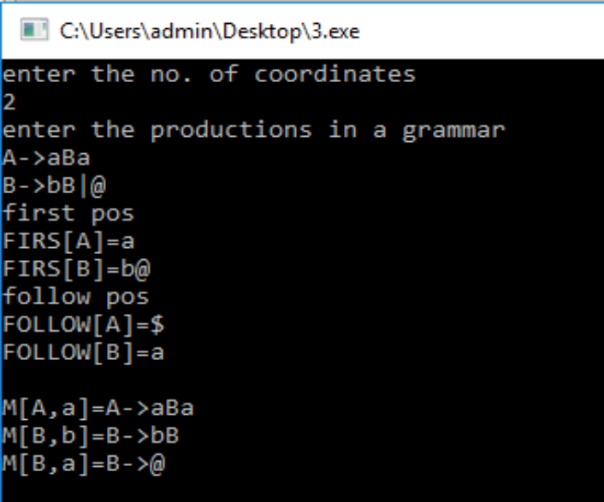

String abba$ is valid string

5. Design, develop and implement a C/Java program to generate the machine code using Triples for the statement A = -B * (C +D) whose intermediate code in three-address form:
T1 = -B
T2 = C + D
T3 = T1 * T2
A = T3

#include<stdio.h>
#include<stdlib.h>
#include<ctype.h>
char op[2],arg1[5],arg2[5],result[5];
void main()
{
FILE *fp1,*fp2;
fp1=fopen("input.txt","r");
fp2=fopen("output.txt","w");
while(!feof(fp1))
{
fscanf(fp1,"%s%s%s%s",result,arg1,op,arg2);
if(strcmp(op,"+")==0)
{
fprintf(fp2,"\nMOV R0,%s",arg1);
fprintf(fp2,"\nADD R0,%s",arg2);
fprintf(fp2,"\nMOV %s,R0",result);
}
if(strcmp(op,"*")==0)
{
fprintf(fp2,"\nMOV R0,%s",arg1);
fprintf(fp2,"\nMUL R0,%s",arg2);
fprintf(fp2,"\nMOV %s,R0",result);
}
if(strcmp(op,"-")==0)
{
fprintf(fp2,"\nMOV R0,%s",arg1);
fprintf(fp2,"\nSUB R0,%s",arg2);
fprintf(fp2,"\nMOV %s,R0",result);
}
if(strcmp(op,"/")==0)
{
fprintf(fp2,"\nMOV R0,%s",arg1);
fprintf(fp2,"\nDIV R0,%s",arg2);
fprintf(fp2,"\nMOV %s,R0",result);
}
if(strcmp(op,"=")==0)
{
fprintf(fp2,"\nMOV R0,%s",arg1);
fprintf(fp2,"\nMOV %s,R0",result);
}
}
fclose(fp1);
fclose(fp2);
getch();
}

Output:
input.txt
T1 -B = ?
T2 C + D
T3 T1 * T2
A T3 = ?
output.txt
MOV R0,-B
MOV T1,R0
MOV R0,C
ADD R0,D
MOV T2,R0
MOV R0,T1
MUL R0,T2
MOV T3,R0
MOV R0,T3
MOV A,R0

6. a) Write a LEX program to eliminate comment lines in a C program and copy the resulting program into a separate file.

%{
#include<stdio.h>
int c_count=0;
%}
%%
"/*"[^*/]*"*/" {c_count++;} /*for single and multiple line comments*/
"//".* {c_count++;} /*for single line comments*/
%%
int main( int argc, char **argv)
{
FILE *f1,*f2;
if(argc>1) /*Pass two filenames for execution*/
{
f1=fopen(argv[1],"r"); /*open first file for reading*/
if(!f1) /*not able to open file*/
{
printf("file error \n");
exit(1);
}
yyin=f1;
f2=fopen(argv[2],"w"); /*open second file for writing*/
if(!f2) /*not able to open file*/
{
printf("Error");
exit(1);
}
yyout=f2;
yylex();
printf("Number of Comment Lines: %d\n",c_count);
}
return 0;
}
OUTPUT:
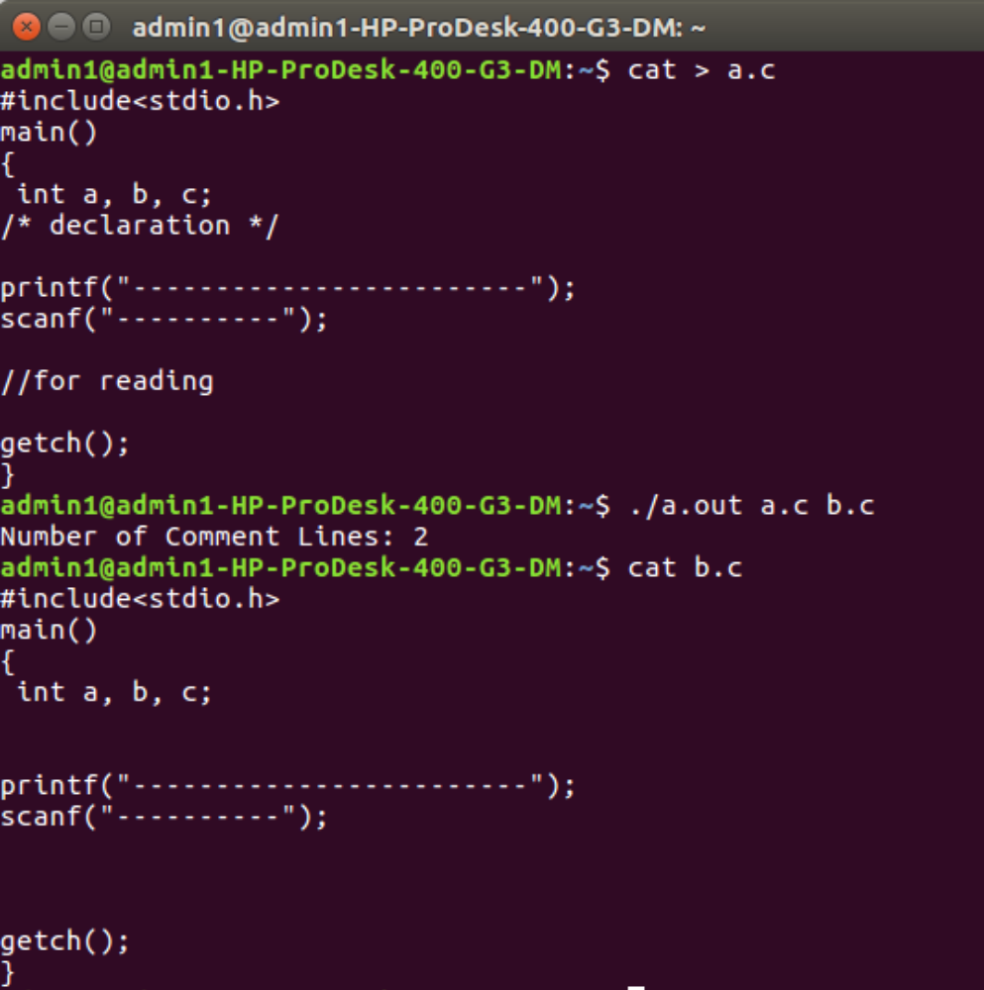

b) Write YACC program to recognize valid identifier, operators and keywords in the given text (C program) file.
Lex File
%{
#include <stdio.h>
#include "y.tab.h"
extern yylval;
%}
%%
[ \t] ;
[+|-|*|/|=|<|>] {printf("operator is %s\n",yytext);return OP;}
[0-9]+ {yylval = atoi(yytext); printf("numbers is %d\n",yylval); return DIGIT;}
int|char|bool|float|void|for|do|while|if|else|return|void {printf("keyword is
%s\n",yytext);return KEY;}
[a-zA-Z0-9]+ {printf("identifier is %s\n",yytext);return ID;}
. ;
%%
Yacc File
%{
#include <stdio.h>
#include <stdlib.h>
int id=0, dig=0, key=0, op=0;
%}
%token DIGIT ID KEY OP
%%
input:
DIGIT input { dig++; }
| ID input { id++; }
| KEY input { key++; }
| OP input {op++;}
| DIGIT { dig++; }
| ID { id++; }
| KEY { key++; }
| OP { op++;}
;
%%
#include <stdio.h>
extern int yylex();
extern int yyparse();
extern FILE *yyin;
Void main()
{
FILE *myfile = fopen("sam_input.c", "r");
if (!myfile) {
printf("I can't open sam_input.c!");
return -1;
}
yyin = myfile;
do {
yyparse();
} while (!feof(yyin));
printf("numbers = %d\nKeywords = %d\nIdentifiers = %d\noperators = %d\n",
dig, key,id, op);
}
void yyerror() {
printf("EEK, parse error! Message: ");
exit(-1);
}

Output :
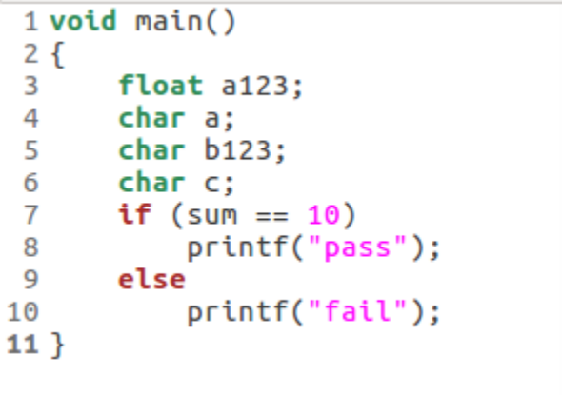
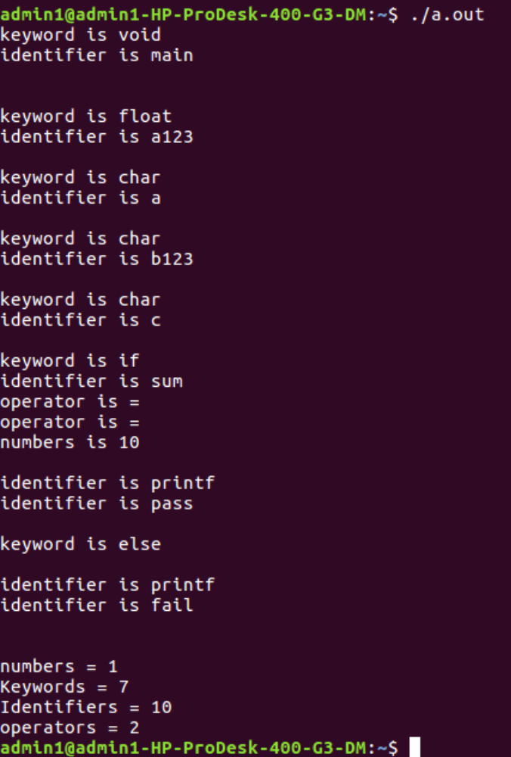

7. Design, develop and implement a C/C++/Java program to simulate the working of Shortest remaining time and Round Robin (RR) scheduling algorithms. Experiment with different quantum sizes for RR algorithm.

#include<stdio.h>
struct proc
{
int id;
int arrival;
int burst;
int rem;
int wait;
int finish;
int turnaround;
float ratio;
}process[10]; //structure to hold the process information
struct proc temp;
int no;
int chkprocess(int);
int nextprocess();
void roundrobin(int, int, int[], int[]);
void srtf(int);
main()
{
int n,tq,choice;
int bt[10],st[10],i,j,k;
for(; ;)
{
printf("Enter the choice \n");
printf(" 1. Round Robin\n 2. SRT\n 3. Exit \n");
scanf("%d",&choice);
switch(choice)
{
case 1:
printf("Round Robin scheduling algorithm\n");
printf("Enter number of processes:\n");
scanf("%d",&n);
printf("Enter burst time for sequences:");
for(i=0;i<n;i++)
{
scanf("%d",&bt[i]);
st[i]=bt[i]; //service time
}
printf("Enter time quantum:");
scanf("%d",&tq);
roundrobin(n,tq,st,bt);
break;
case 2:
printf("\n \n ---SHORTEST REMAINING TIME NEXT---\n \n ");
printf("\n \n Enter the number of processes: ");
scanf("%d", &n);
srtf(n);
break;
case 3: exit(0);
} // end of switch
} // end of for
} //end of main()
void roundrobin(int n,int tq,int st[],int bt[])
{
int time=0;
int tat[10],wt[10],i,count=0,swt=0,stat=0,temp1,sq=0,j,k;
float awt=0.0,atat=0.0;
while(1)
{
for(i=0,count=0;i<n;i++)
{
temp1=tq;
if(st[i]==0) // when service time of a process equals zero then
//count value is incremented
{
count++;
continue;
}
if(st[i]>tq) // when service time of a process greater than time
//quantum then time
st[i]=st[i]-tq; //quantum value subtracted from service time
else
if(st[i]>=0)
{
temp1=st[i]; // temp1 stores the service time of a process
st[i]=0; // making service time equals 0
}
sq=sq+temp1; // utilizing temp1 value to calculate turnaround time
tat[i]=sq; // turn around time
} //end of for
if(n==count) // it indicates all processes have completed their task
//because the count value
break; // incremented when service time equals 0
} //end of while
for(i=0;i<n;i++) // to calculate the wait time and turnaround time of each process
{
wt[i]=tat[i]-bt[i]; // waiting time calculated from the turnaround time - burst
time
swt=swt+wt[i]; // summation of wait time
stat=stat+tat[i]; // summation of turnaround time
}
awt=(float)swt/n; // average wait time
atat=(float)stat/n; // average turnaround time
printf("Process_no Burst time Wait time Turn around time\n");
for(i=0;i<n;i++)
printf("%d\t\t%d\t\t%d\t\t%d\n",i+1,bt[i],wt[i],tat[i]);
printf("Avg wait time is %f\n Avg turn around time is %f\n",awt,atat);
} // end of Round Robin
int chkprocess(int s) // function to check process remaining time is zero or not
{
int i;
for(i = 1; i <= s; i++)
{
if(process[i].rem != 0)
return 1;
}
return 0;
} // end of chkprocess
int nextprocess() // function to identify the next process to be executed
{
int min, l, i;
min = 32000; //any limit assumed
for(i = 1; i <= no; i++)
{
if( process[i].rem!=0 && process[i].rem < min)
{
min = process[i].rem;
l = i;
}
}
return l;
} // end of nextprocess
void srtf(int n)
{
int i,j,k,time=0;
float tavg,wavg;
for(i = 1; i <= n; i++)
{
process[i].id = i;
printf("\n\nEnter the arrival time for process %d: ", i);
scanf("%d", &(process[i].arrival));
printf("Enter the burst time for process %d: ", i);
scanf("%d", &(process[i].burst));
process[i].rem = process[i].burst;
}
for(i = 1; i <= n; i++)
{
for(j = i + 1; j <= n; j++)
{
if(process[i].arrival > process[j].arrival) // sort arrival time of a process
{
temp = process[i];
process[i] = process[j];
process[j] = temp;
}
}
}
no = 0;
j = 1;
while(chkprocess(n) == 1)
{
if(process[no + 1].arrival == time)
{
while(process[no+1].arrival==time)
no++;
if(process[j].rem==0)
process[j].finish=time;
j = nextprocess();
}
if(process[j].rem != 0) // to calculate the waiting time of a process
{
process[j].rem--;
for(i = 1; i <= no; i++)
{
if(i != j && process[i].rem != 0)
process[i].wait++;
}
}
else
{
process[j].finish = time;
j=nextprocess();
time--;
k=j;
}
time++;
}
process[k].finish = time;
printf("\n\n\t\t\t---SHORTEST REMAINING TIME FIRST---");
printf("\n\n Process Arrival Burst Waiting Finishing turnaround Tr/Tb \n");
printf("%5s %9s %7s %10s %8s %9s\n\n", "id", "time", "time", "time", "time", "time");
for(i = 1; i <= n; i++)
{
process[i].turnaround = process[i].wait + process[i].burst; // calc of turnaround
process[i].ratio = (float)process[i].turnaround / (float)process[i].burst;
printf("%5d %8d %7d %8d %10d %9d %10.1f ", process[i].id, process[i].arrival,
process[i].burst, process[i].wait, process[i].finish, process[i].turnaround,
process[i].ratio);
tavg=tavg+ process[i].turnaround; //summation of turnaround time
wavg=wavg+process[i].wait; // summation of waiting time
printf("\n\n");
}
tavg=tavg/n; // average turnaround time
wavg=wavg/n; // average wait time
printf("tavg=%f\t wavg=%f\n",tavg,wavg);
}
// end of srtf
Output:
Enter the choice
1) Round Robin 2) SRT
3) Exit
1
Round Robin scheduling algorithm
**********************************
Enter number of processes:3
Enter burst time for sequences:24
3
3
Enter time quantum:4
Process_no Burst time Wait time Turnaround time
1 24 6 30
2 3 4 7
3 3 7 10
Avg wait time is 5.666667
Avg turnaround time is 15.666667
Enter the choice
1) Round Robin 2) SRT
3) Exit
2
---SHORTEST REMAINING TIME NEXT---
Enter the number of processes: 4
Enter the arrival time for process 1: 0
Enter the burst time for process 1: 8
Enter the arrival time for process 2: 1
Enter the burst time for process 2: 4
Enter the arrival time for process 3: 2
Enter the burst time for process 3: 9
Enter the arrival time for process 4: 3
Enter the burst time for process 4: 5
1 24 6 30
2 3 4 7
3 3 7 10
---SHORTEST REMAINING TIME FIRST---
Enter the number of processes: 4
Enter the arrival time for process 1: 0
Enter the burst time for process 1: 8
Enter the arrival time for process 2: 1
Enter the burst time for process 2: 4
Enter the arrival time for process 3: 2
Enter the burst time for process 3: 9
Enter the arrival time for process 4: 3
Enter the burst time for process 4: 5
---SHORTEST REMAINING TIME NEXT---
Process Arrival Burst Waiting Finishing turnaround Tr/Tb
id time time time time time time
1 0 8 9 17 17 2.1
2 1 4 0 5 4 1.0
3 2 9 15 26 24 2.7
4 3 5 2 10 7 1.4
tavg=13.000000
wavg=6.500000
Using OpenMP

8. Design, develop and implement a C/C++/Java program to implement Banker’s algorithm. Assume suitable input required to demonstrate the results.
#include <stdio.h>
#include <stdlib.h>
int main()
{
int Max[10][10], need[10][10], alloc[10][10], avail[10], completed[10],
safeSequence[10];
int p, r, i, j, process, count;
count = 0;
printf("Enter the no of processes : ");
scanf("%d", &p);
for(i = 0; i< p; i++)
completed[i] = 0;
printf("\n\nEnter the no of resources : ");
scanf("%d", &r);
printf("\n\nEnter the Max Matrix for each process : ");
for(i = 0; i < p; i++)
{
printf("\nFor process %d : ", i + 1);
for(j = 0; j < r; j++)
scanf("%d", &Max[i][j]);
}
printf("\n\nEnter the allocation for each process : ");
for(i = 0; i < p; i++)
{
printf("\nFor process %d : ",i + 1);
for(j = 0; j < r; j++)
scanf("%d", &alloc[i][j]);
}
printf("\n\nEnter the Available Resources : ");
for(i = 0; i < r; i++)
scanf("%d", &avail[i]);
for(i = 0; i < p; i++)
for(j = 0; j < r; j++)
need[i][j] = Max[i][j] - alloc[i][j];
do
{
printf("\n Max matrix:\tAllocation matrix:\n");
for(i = 0; i < p; i++)
{
for( j = 0; j < r; j++)
printf("%d ", Max[i][j]);
printf("\t\t");
for( j = 0; j < r; j++)
printf("%d ", alloc[i][j]);
printf("\n");
}
process = -1;
for(i = 0; i < p; i++)
{
if(completed[i] == 0)//if not completed
{
process = i ;
for(j = 0; j < r; j++)
{
if(avail[j] < need[i][j])
{
process = -1;
break;
}
}
}
if(process != -1)
break;
}
if(process != -1)
{
printf("\nProcess %d runs to completion!", process + 1);
safeSequence[count] = process + 1;
count++;
for(j = 0; j < r; j++)
{
avail[j] += alloc[process][j];
alloc[process][j] = 0;
Max[process][j] = 0;
completed[process] = 1;
}
}
}
while(count != p && process != -1);
if(count == p)
{
printf("\nThe system is in a safe state!!\n");
printf("Safe Sequence : < ");
for( i = 0; i < p; i++)
printf("%d ", safeSequence[i]);
printf(">\n");
}
else
printf("\nThe system is in an unsafe state!!");
}
Output:
Enter the no of processes : 5
Enter the no of resources : 3
Enter the Max Matrix for each process :
For process 1 : 7
5
3
For process 2 : 3
2
2
For process 3 : 7
0
2
For process 4 : 2
2
2
For process 5 : 4
3
3
Enter the allocation for each process :
For process 1 : 0
1
0
For process 2 : 2
0
0
For process 3 : 3
0
2
For process 4 : 2
1
1
For process 5 : 0
0
2
Enter the Available Resources : 3
3
2
Max matrix: Allocation matrix:
7 5 3 0 1 0
3 2 2 2 0 0
7 0 2 3 0 2
2 2 2 2 1 1
4 3 3 0 0 2
Process 2 runs to completion!
Max matrix: Allocation matrix:
7 5 3 0 1 0
0 0 0 0 0 0
7 0 2 3 0 2
2 2 2 2 1 1
4 3 3 0 0 2
Process 3 runs to completion!
Max matrix: Allocation matrix:
7 5 3 0 1 0
0 0 0 0 0 0
0 0 0 0 0 0
2 2 2 2 1 1
4 3 3 0 0 2
Process 4 runs to completion!
Max matrix: Allocation matrix:
7 5 3 0 1 0
0 0 0 0 0 0
0 0 0 0 0 0
0 0 0 0 0 0
4 3 3 0 0 2
Process 1 runs to completion!
Max matrix: Allocation matrix:
0 0 0 0 0 0
0 0 0 0 0 0
0 0 0 0 0 0
0 0 0 0 0 0
4 3 3 0 0 2
Process 5 runs to completion!
The system is in a safe state!!
Safe Sequence: < 2 3 4 1 5 >
9. Design, develop and implement a C/C++/Java program to implement page replacement algorithms LRU and FIFO. Assume suitable input required to demonstrate the results.
#include<stdio.h>
#include<stdlib.h>
void FIFO(char [ ],char [ ],int,int);
void lru(char [ ],char [ ],int,int);
void opt(char [ ],char [ ],int,int);
int main()
{
int ch,YN=1,i,l,f;
char F[10],s[25];
printf("\n\n\tEnter the no of empty frames: ");
scanf("%d",&f);
printf("\n\n\tEnter the length of the string: ");
scanf("%d",&l);
printf("\n\n\tEnter the string: ");
scanf("%s",s);
for(i=0;i<f;i++)
F[i]=-1;
do
{
printf("\n\n\t*********** MENU ***********");
printf("\n\n\t1:FIFO\n\n\t2:LRU \n\n\t4:EXIT");
printf("\n\n\tEnter your choice: ");
scanf("%d",&ch);
switch(ch)
{
case 1:
for(i=0;i<f;i++)
{
F[i]=-1;
}
FIFO(s,F,l,f);
break;
case 2:
for(i=0;i<f;i++)
{
F[i]=-1;
}
lru(s,F,l,f);
break;
case 4:
exit(0);
}
printf("\n\n\tDo u want to continue IF YES PRESS 1\n\n\tIF NO PRESS 0 : ");
scanf("%d",&YN);
}while(YN==1);return(0);
}
//FIFO
void FIFO(char s[],char F[],int l,int f)
{
int i,j=0,k,flag=0,cnt=0;
printf("\n\tPAGE\t FRAMES\t FAULTS");
for(i=0;i<l;i++)
{
for(k=0;k<f;k++)
{
if(F[k]==s[i])
flag=1;
}
if(flag==0)
{
printf("\n\t%c\t",s[i]);
F[j]=s[i];
j++;
for(k=0;k<f;k++)
{
printf(" %c",F[k]);
}
printf("\tPage-fault%d",cnt);
cnt++;
}
else
{
flag=0;
printf("\n\t%c\t",s[i]);
for(k=0;k<f;k++)
{
printf(" %c",F[k]);
}
printf("\tNo page-fault");
}
if(j==f)
j=0;
}
}
//LRU
void lru(char s[],char F[],int l,int f)
{
int i,j=0,k,m,flag=0,cnt=0,top=0;
printf("\n\tPAGE\t FRAMES\t FAULTS");
for(i=0;i<l;i++)
{
for(k=0;k<f;k++)
{
if(F[k]==s[i])
{
flag=1;
break;
}
}
printf("\n\t%c\t",s[i]);
if(j!=f && flag!=1)
{
F[top]=s[i];
j++;
if(j!=f)
top++;
}
else
{
if(flag!=1)
{
for(k=0;k<top;k++)
{
F[k]=F[k+1];
}
F[top]=s[i];
}
if(flag==1)
{
for(m=k;m<top;m++)
{
F[m]=F[m+1];
}
F[top]=s[i];
}
}
for(k=0;k<f;k++)
{
printf(" %c",F[k]);
}
if(flag==0)
{
printf("\tPage-fault%d",cnt);
cnt++;
}
else
printf("\tNo page fault");
flag=0;
}
}
Output:
Enter the no of empty frames: 3
Enter the length of the string: 5
Enter the string: hello
*********** MENU ***********
1:FIFO
2:LRU
4:EXIT
Enter your choice: 1
PAGE FRAMES FAULTS
h h Page-fault 0
e h e Page-fault 1
l h e l Page-fault 2
l h e l No page-fault
o o e l Page-fault 3
Do u want to continue IF YES PRESS 1
IF NO PRESS 0 : 1
*********** MENU ***********
1:FIFO
2:LRU
4:EXIT
Enter your choice: 2
PAGE FRAMES FAULTS
h h Page-fault 0
e h e Page-fault 1
l h e l Page-fault 2
l h e l No page fault
o e l o Page-fault 3
Do u want to continue IF YES PRESS 1
IF NO PRESS 0 : 1
*********** MENU ***********
1:FIFO
2:LRU
4:EXIT
Enter your choice: 4

10. a) Design, develop and implement a C/C++/Java program to simulate a numerical calculator

#include <stdio.h>
void main()
{
char operator;
float num1, num2, result;
printf("Simulation of a Simple Calculator\n");
printf("*********************************\n");
printf("Enter two numbers \n");
scanf("%f %f", &num1, &num2);
fflush(stdin);
printf("Enter the operator [+,-,*,/] \n");
scanf("%s", &operator);
switch(operator)
{
case '+': result = num1 + num2;
break;
case '-': result = num1 - num2;
break;
case '*': result = num1 * num2;
break;
case '/': result = num1 / num2;
break;
default : printf("Error in operationn");
break;
}
printf("\n %5.2f %c %5.2f = %5.2f\n", num1, operator, num2, result);
}

Output:
Simulation of a Simple Calculator
*********************************
Enter two numbers
2
3
Enter the operator [+,-,*,/]
+
2.00 + 3.00 = 5.00

b) Design, develop and implement a C/C++/Java program to simulate page replacement technique
#include<stdio.h>
int n,nf;
int in[100];
int p[50];
int hit=0;
int i,j,k;
int pgfaultcnt=0;
void getData()
{
printf("\nEnter length of page reference sequence:");
scanf("%d",&n);
printf("\nEnter the page reference sequence:");
for(i=0; i<n; i++)
scanf("%d",&in[i]);
printf("\nEnter no of frames:");
scanf("%d",&nf);
}
void initialize()
{
pgfaultcnt=0;
for(i=0; i<nf; i++)
p[i]=9999;
}
int isHit(int data)
{
hit=0;
for(j=0; j<nf; j++)
{
if(p[j]==data)
{
hit=1;
break;
}
}
return hit;
}
int getHitIndex(int data)
{
int hitind;
for(k=0; k<nf; k++)
{
if(p[k]==data)
{
hitind=k;
break;
}
}
return hitind;
}
void dispPages()
{
for (k=0; k<nf; k++)
{
if(p[k]!=9999)
printf(" %d",p[k]);
}
}
void dispPgFaultCnt()
{
printf("\nTotal no of page faults:%d",pgfaultcnt);
}
void fifo()
{
initialize();
for(i=0; i<n; i++)
{
printf("\nFor %d :",in[i]);
if(isHit(in[i])==0)
{
for(k=0; k<nf-1; k++)
p[k]=p[k+1];
p[k]=in[i];
pgfaultcnt++;
dispPages();
}
else
printf("No page fault");
}
dispPgFaultCnt();
}
void optimal()
{
initialize();
int near[50];
for(i=0; i<n; i++)
{
printf("\nFor %d :",in[i]);
if(isHit(in[i])==0)
{
for(j=0; j<nf; j++)
{
int pg=p[j];
int found=0;
for(k=i; k<n; k++)
{
if(pg==in[k])
{
near[j]=k;
found=1;
break;
}
else
found=0;
}
if(!found)
near[j]=9999;
}
int max=-9999;
int repindex;
for(j=0; j<nf; j++)
{
if(near[j]>max)
{
max=near[j];
repindex=j;
}
}
p[repindex]=in[i];
pgfaultcnt++;
dispPages();
}
else
}
dispPgFaultCnt();
}
void lru()
{
initialize();
int least[50];
for(i=0; i<n; i++)
{
printf("\nFor %d :",in[i]);
if(isHit(in[i])==0)
{
for(j=0; j<nf; j++)
{
int pg=p[j];
int found=0;
for(k=i-1; k>=0; k--)
{
if(pg==in[k])
{
least[j]=k;
found=1;
break;
}
else
found=0;
}
if(!found)
least[j]=-9999;
}
int min=9999;
int repindex;
for(j=0; j<nf; j++)
{
if(least[j]<min)
{
min=least[j];
repindex=j;
}
}
p[repindex]=in[i];
pgfaultcnt++;
dispPages();
}
else
printf("No page fault!");
}
dispPgFaultCnt();
}
void lfu()
{
int usedcnt[100];
int least,repin,sofarcnt=0,bn;
initialize();
for(i=0; i<nf; i++)
usedcnt[i]=0;
for(i=0; i<n; i++)
{
printf("\n For %d :",in[i]);
if(isHit(in[i]))
{
int hitind=getHitIndex(in[i]);
usedcnt[hitind]++;
printf("No page fault!");
}
else
{
pgfaultcnt++;
if(bn<nf)
{
p[bn]=in[i];
usedcnt[bn]=usedcnt[bn]+1;
bn++;
}
else
{
least=9999;
for(k=0; k<nf; k++)
if(usedcnt[k]<least)
{
least=usedcnt[k];
repin=k;
}
p[repin]=in[i];
sofarcnt=0;
for(k=0; k<=i; k++)
if(in[i]==in[k])
sofarcnt=sofarcnt+1;
usedcnt[repin]=sofarcnt;
}
dispPages();
}
}
dispPgFaultCnt();
}
void secondchance()
{
int usedbit[50];
int victimptr=0;
initialize();
for(i=0; i<nf; i++)
usedbit[i]=0;
for(i=0; i<n; i++)
{
printf("\nFor %d:",in[i]);
if(isHit(in[i]))
{
printf("No page fault!");
int hitindex=getHitIndex(in[i]);
if(usedbit[hitindex]==0)
usedbit[hitindex]=1;
}
else
{
pgfaultcnt++;
if(usedbit[victimptr]==1)
{
do
{
usedbit[victimptr]=0;
victimptr++;
if(victimptr==nf)
victimptr=0;
}
while(usedbit[victimptr]!=0);
}
if(usedbit[victimptr]==0)
{
p[victimptr]=in[i];
usedbit[victimptr]=1;
victimptr++;
}
dispPages();
}
if(victimptr==nf)
victimptr=0;
}
dispPgFaultCnt();
}
int main()
{
int choice;
while(1)
{
printf("\nPage Replacement Algorithms\n1.Enter data\n2.FIFO\n3.Optimal\n4.LRU\n5.LFU\n6.Second Chance\n7.Exit\nEnter your choice:");
scanf("%d",&choice);
switch(choice)
{
case 1:
getData();
break;
case 2:
fifo();
break;
case 3:
optimal();
break;
case 4:
lru();
break;
case 5:
lfu();
break;
case 6:
secondchance();
break;
default:
return 0;
break;
}
}
}
Output:
Page Replacement Algorithms
1.Enter data
2.FIFO
3.Optimal
4.LRU
5.LFU
6.Second Chance
7.Exit
Enter your choice:1
Enter length of page reference sequence:8
Enter the page reference sequence:2
3
4
2
3
5
6
2
Enter no of frames:3
Page Replacement Algorithms
1.Enter data
2.FIFO
3.Optimal
4.LRU
5.LFU
6.Second Chance
7.Exit
Enter your choice:2
For 2 : 2
For 3 : 2 3
For 4 : 2 3 4
For 2 :No page fault
For 3 :No page fault
For 5 : 3 4 5
For 6 : 4 5 6
For 2 : 5 6 2
Total no of page faults:6
Page Replacement Algorithms
1.Enter data
2.FIFO
3.Optimal
4.LRU
5.LFU
6.Second Chance
7.Exit
Enter your choice:3
For 2 : 2
For 3 : 2 3
For 4 : 2 3 4
For 2 :No page fault
For 3 :No page fault
For 5 : 2 5 4
For 6 : 2 6 4
For 2 :No page fault
Total no of page faults:5
Page Replacement Algorithms
1.Enter data
2.FIFO
3.Optimal
4.LRU
5.LFU
6.Second Chance
7.Exit
Enter your choice:4
For 2 : 2
For 3 : 2 3
For 4 : 2 3 4
For 2 :No page fault!
For 3 :No page fault!
For 5 : 2 3 5
For 6 : 6 3 5
For 2 : 6 2 5
Total no of page faults:6
Page Replacement Algorithms
1.Enter data
2.FIFO
3.Optimal
4.LRU
5.LFU
6.Second Chance
7.Exit
Enter your choice:5
For 2 : 2
For 3 : 2 3
For 4 : 2 3 4
For 2 :No page fault!
For 3 :No page fault!
For 5 : 2 3 5
For 6 : 2 3 6
For 2 :No page fault!
Total no of page faults:5
Page Replacement Algorithms
1.Enter data
2.FIFO
3.Optimal
4.LRU
5.LFU
6.Second Chance
7.Exit
Enter your choice:7

SAMPLE Viva Questions
- Define system software.
System software is computer software designed to operate the computer hardware and to provide a platform for running application software. Eg: operating system, assembler, and loader.
- What is an Assembler?
Assembler for an assembly language, a computer program to translate between lower-level representations of computer programs.
- Explain lex and yacc tools
Lex: - scanner that can identify those tokens
Yacc: - parser.yacc takes a concise description of a grammar and produces a C routine that can parse that grammar.
- Explain yyleng?
Yyleng-contains the length of the string our lexer recognizes.
- What is a Parser?
A Parser for a Grammar is a program which takes in the Language string as it's input and produces either a corresponding Parse tree or an Error.
- What is the Syntax of a Language?
The Rules which tells whether a string is a valid Program or not are called the Syntax.
- What is the Semantics of a Language?
The Rules which gives meaning to programs are called the Semantics of a Language.
- What are tokens?
When a string representing a program is broken into sequence of substrings, such that each substring represents a constant, identifier, operator, keyword etc of the language, these substrings are called the tokens of the Language.
- What is the Lexical Analysis?
The Function of a lexical Analyzer is to read the input stream representing the Source program, one character at a time and to translate it into valid tokens.
- How can we represent a token in a language?
The Tokens in a Language are represented by a set of Regular Expressions. A regular expression specifies a set of strings to be matched. It contains text characters and operator characters. The Advantage of using regular expression is that a recognizer can be automatically generated.
- How are the tokens recognized?
The tokens which are represented by an Regular Expressions are recognized in an input string by means of a state transition Diagram and Finite Automata.
- Are Lexical Analysis and Parsing two different Passes?
These two can form two different passes of a Parser. The Lexical analysis can store all the recognized tokens in an intermediate file and give it to the Parser as an input. However it is more convenient to have the lexical Analyzer as a co routine or a subroutine which the Parser calls whenever it requires a token.
- What are the Advantages of using Context-Free grammars?
It is precise and easy to understand.
It is easier to determine syntactic ambiguities and conflicts in the grammar.
- If Context-free grammars can represent every regular expression, why do one needs R.E at all?
Regular Expression are Simpler than Context-free grammars.
It is easier to construct a recognizer for R.E than Context-Free grammar.
Breaking the Syntactic structure into Lexical & non-Lexical parts provide better front end for the Parser.
R.E are most powerful in describing the lexical constructs like identifiers, keywords etc while Context-free grammars in representing the nested or block structures of the Language.
- What are the Parse Trees?
Parse trees are the Graphical representation of the grammar which filters out the choice for replacement order of the Production rules.
- What are Terminals and non-Terminals in a grammar?
Terminals:- All the basic symbols or tokens of which the language is composed of are called Terminals. In a Parse Tree the Leafs represents the Terminal Symbol.
Non-Terminals:- These are syntactic variables in the grammar which represents a set of strings the grammar is composed of. In a Parse tree all the inner nodes represents the Non-Terminal symbols.
- What are Ambiguous Grammars?
A Grammar that produces more than one Parse Tree for the same sentences or the Production rules in a grammar is said to be ambiguous.
- What is bottom up Parsing?
The Parsing method is which the Parse tree is constructed from the input language string beginning from the leaves and going up to the root node.
Bottom-Up parsing is also called shift-reduce parsing due to its implementation. The YACC supports shift-reduce parsing.
- What is the need of Operator precedence?
The shift reduce Parsing has a basic limitation. Grammars which can represent a left-sentential parse tree as well as right-sentential parse tree cannot be handled by shift reduce parsing. Such a grammar ought to have two non-terminals in the production rule. So the Terminal sandwiched between these two non-terminals must have some associability and precedence. This will help the parser to understand which non-terminal would be expanded first.
- What is exit status command?
Exit 0- return success, command executed successfully.
Exit 1 – return failure.
- Define API’s
An application programming interface (API) is a source code based specification intended to be used as an interface by software components to communicate with each other.

